
DEPARTMENT OF COMPUTER SCIENCE AND ENGINEERING
2026 – 2027 (ODD SEMESTER)
CS2307 – INTERNET PROGRAMMING LAB
Online Job Portal

Abstract
The Online Job Portal is a web-based platform designed to connect job seekers with employers and simplify the recruitment process. In a traditional job search, candidates rely on newspapers, consultancies, or scattered listings, while employers manually collect and shortlist resumes, which is slow and difficult to manage.
The proposed system, JobConnect, provides a centralised platform where job seekers can register, build a profile, search for jobs by category and location, and apply directly online. Registered candidates can track the status of every application they have submitted.
Employers have a separate login through which they can post new job openings, specify required skills and experience, and view the list of candidates who applied for each posting. The admin has overall control to approve job postings, manage users, and monitor platform activity through a dashboard that displays statistics such as total jobs, registered candidates, employers, and applications received.
The system is developed using HTML5, CSS3, JavaScript, PHP, and MariaDB. XAMPP is used as the local development environment, and phpMyAdmin is used to manage the database. PHP handles server-side processing such as authentication and application tracking, while MariaDB stores candidate, employer, job, and application information.
The main purpose of the project is to provide a simple, fast, and reliable way for job seekers to find suitable openings, while giving employers an efficient way to advertise vacancies and manage applicants.

Introduction
Recruitment is a critical process for both individuals and organisations, and the way job vacancies are advertised and applied for has changed rapidly with the growth of web technology. A traditional job search depends on newspaper advertisements, walk-in interviews, or consultancies, and involves manual resume collection and shortlisting by the employer. This process is slow, difficult to scale, and often leads to delayed communication with candidates.
An online job portal solves these problems by letting a candidate search and apply for jobs from any device, and track the status of an application without visiting the company in person. On the employer side, an online platform gives a single organised place to post vacancies, manage a pool of applicants, and shortlist candidates, instead of maintaining scattered paper resumes and spreadsheets.
The Online Job Portal (JobConnect) proposed in this project is a role-based web application built around three kinds of users. A job seeker can register, build a profile, search jobs by category and location, and apply to a posting. An employer can register a company profile, post job openings, and review the list of applicants for each job. An administrator approves new job postings, manages user accounts, and monitors overall platform activity.
The system is built with HTML5, CSS3, and JavaScript on the front end for structure, styling, form validation, and client-side interaction, and PHP with a MariaDB database on the back end for authentication, application handling, and data storage. XAMPP is used to run Apache and MariaDB locally, and phpMyAdmin is used for database administration during development.
This report describes the objectives, modules, design approach, and implementation of the system, followed by the references used during development and a conclusion summarising the outcome and possible future enhancements.

Objectives of the Project
The main objective of this project is to develop a simple and efficient web-based job portal that benefits both job seekers and employers.
Primary Objectives
- To develop an online system for posting and searching job vacancies.
- To provide separate login facilities for job seekers, employers, and administrators.
- To allow job seekers to build a profile and apply to jobs online.
- To allow employers to post job openings and view applicants.
- To allow job seekers to track the status of their applications.
- To allow administrators to approve job postings and manage users.
- To allow administrators to monitor overall platform activity and statistics.
Secondary Objectives
- To provide a simple and user-friendly interface.
- To maintain category-wise and location-wise job listings.
- To allow filtering of jobs by required skills and experience.
- To prevent duplicate applications to the same job by a candidate.
- To restrict job approval and user management to authorised admin users.
- To provide a foundation that can be expanded in the future.

Modules Description
The system is organised into the following functional modules, each responsible for a distinct part of the recruitment workflow.
4.1 Login Module
The login module provides separate login access for:
- Job Seekers
- Employers
- Administrators
Users enter their login credentials and are redirected to their respective dashboards.
4.2 Job Seeker Module
Job seekers can:
- Login / Register to the system.
- Create and update their profile with skills and resume details.
- Search and filter jobs by category, location, and experience.
- Apply to a job posting.
- View the status of each application (Pending, Shortlisted, Rejected).
- View their complete application history.
- Logout from the system.
4.3 Employer Module
Employers can:
- Login / Register a company profile.
- Post a new job opening with title, description, and required skills.
- Edit or close an existing job posting.
- View the list of candidates who applied for each job.
- Update the status of an application (Shortlist / Reject).
4.4 Job Module
This module stores and displays job information such as:
- Job title and category
- Company name and location
- Required skills and experience
- Salary range and job type (Full-time, Part-time, Internship)
4.5 Application Module
The application module stores:
- Candidate
- Job applied for
- Date of application
- Current status of the application
The system automatically prevents a candidate from applying twice to the same job posting.
4.6 Admin Module
Administrators can:
- Login to the system.
- Approve or reject newly posted jobs.
- Manage job seeker and employer accounts.
- View all applications submitted across the platform.
- View platform statistics such as total jobs, employers, candidates, and applications.
4.7 Database Module
MariaDB is used to store:
- Job seeker details
- Employer details
- Job postings
- Application records

Methodology / Approach
The project was developed using a structured web application development approach.
5.1 Requirement Analysis
The requirements of the job portal were identified first.
Job Seeker Requirements
- Login / Register
- Build and edit profile
- Search and apply for jobs
- Track application status
- Logout
Employer Requirements
- Login / Register
- Post and manage jobs
- View and shortlist applicants
- Logout
Admin Requirements
- Login
- Approve jobs
- Manage users
- Logout
5.2 System Design
After identifying the requirements, the application was divided into different modules described above, and the data flow between the job seeker, employer, and admin roles was mapped out.
5.3 Database Design
A relational database was created using MariaDB. The database contains tables for candidates, employers, jobs, and applications. Primary keys and foreign keys are used to maintain relationships between tables, linking each application to a candidate and a job.
5.4 Front-End Development
HTML5 was used to create the structure of the pages. CSS3 was used for:
- Page layout
- Navigation
- Forms
- Job listing cards and filters
- Responsive design
JavaScript was used for form validation, dynamic filtering of job listings, and client-side interaction.
5.5 Back-End Development
PHP was used for server-side processing. PHP handles:
- Login and registration authentication
- Sessions
- Database connection
- Job posting and retrieval
- Application submission and status updates
- Logout
5.6 Database Connectivity
PHP connects to MariaDB using the mysqli extension. The database connection contains the host name, username, password, and database name required to establish the link.
5.7 Testing
The application was tested using different scenarios, such as duplicate applications, invalid login attempts, and job postings with missing fields, to verify that the system handles errors correctly.

Flow of the Project
The following flow describes how a job seeker, an employer, and an administrator move through the system from registration to the final outcome.
Job Seeker Flow
- The job seeker registers on the portal and logs in with the created credentials.
- The job seeker completes their profile by adding skills, qualifications, and experience.
- The job seeker searches or filters job listings by category, location, or experience level.
- The job seeker opens a job posting to view its full description and requirements.
- The job seeker applies to the job; the system checks that a duplicate application does not already exist.
- The application is recorded with a Pending status and linked to the candidate and the job.
- The job seeker tracks the status of the application from their dashboard as it changes to Shortlisted or Rejected.
Employer Flow
- The employer registers a company profile and logs in.
- The employer creates a new job posting with title, description, required skills, experience, and salary.
- The job posting is saved with a Pending status and sent for admin approval.
- Once approved, the job becomes visible to job seekers on the portal.
- The employer views the list of candidates who applied for each posting.
- The employer reviews candidate profiles and updates each application's status to Shortlisted or Rejected.
Admin Flow
- The administrator logs in through a separate admin panel.
- The administrator reviews newly posted jobs awaiting approval.
- The administrator approves or rejects each job posting.
- The administrator manages job seeker and employer accounts as needed.
- The administrator monitors overall platform statistics, including total jobs, employers, candidates, and applications.

Implementation Code
Database Connection – db.php
<?php
$host = "localhost";
$user = "root";
$password = "";
$database = "jobconnect";
$conn = mysqli_connect($host, $user, $password, $database);
if (!$conn) {
die("Connection failed: " . mysqli_connect_error());
}
?>
Candidate Login — login.php
<?php
session_start();
include 'db.php';
if ($_SERVER['REQUEST_METHOD'] == 'POST') {
$email = mysqli_real_escape_string($conn, $_POST['email']);
$password = $_POST['password'];
$sql = "SELECT * FROM candidates WHERE email='$email'";
$result = mysqli_query($conn, $sql);
if (mysqli_num_rows($result) == 1) {
$row = mysqli_fetch_assoc($result);
if (password_verify($password, $row['password'])) {
$_SESSION['candidate_id'] = $row['id'];
$_SESSION['candidate_name'] = $row['name'];
header("Location: dashboard.php");
exit();
} else {
$error = "Invalid password.";
}
} else {
$error = "No account found with this email.";
}
}
?>
Post a Job — post_job.php
<?php
session_start();
include 'db.php';
if (!isset($_SESSION['employer_id'])) {
header("Location: employer_login.php");
exit();
}
if ($_SERVER['REQUEST_METHOD'] == 'POST') {
$employer_id = $_SESSION['employer_id'];
$title = mysqli_real_escape_string($conn, $_POST['title']);
$category = mysqli_real_escape_string($conn, $_POST['category']);
$location = mysqli_real_escape_string($conn, $_POST['location']);
$skills = mysqli_real_escape_string($conn, $_POST['skills']);
$experience = mysqli_real_escape_string($conn, $_POST['experience']);
$salary = mysqli_real_escape_string($conn, $_POST['salary']);
$job_type = mysqli_real_escape_string($conn, $_POST['job_type']);
$description = mysqli_real_escape_string($conn, $_POST['description']);
$sql = "INSERT INTO jobs
(employer_id, title, category, location, skills,
experience, salary, job_type, description, status)
VALUES ('$employer_id', '$title', '$category', '$location',
'$skills', '$experience', '$salary', '$job_type',
'$description', 'Pending')";
if (mysqli_query($conn, $sql)) {
$message = "Job posted successfully. Awaiting admin approval.";
} else {
$message = "Error: " . mysqli_error($conn);
}
}
?>
Apply for a Job — apply_job.php
<?php
session_start();
include 'db.php';
if (!isset($_SESSION['candidate_id'])) {
header("Location: login.php");
exit();
}
$candidate_id = $_SESSION['candidate_id'];
$job_id = intval($_GET['job_id']);
$check = mysqli_query($conn, "SELECT * FROM applications
WHERE candidate_id='$candidate_id' AND job_id='$job_id'");
if (mysqli_num_rows($check) > 0) {
$message = "You have already applied for this job.";
} else {
$sql = "INSERT INTO applications
(candidate_id, job_id, applied_on, status)
VALUES ('$candidate_id', '$job_id', NOW(), 'Pending')";
if (mysqli_query($conn, $sql)) {
$message = "Application submitted successfully.";
} else {
$message = "Error: " . mysqli_error($conn);
}
}
?>
View Applicants — view_applicants.php
<?php
session_start();
include 'db.php';
if (!isset($_SESSION['employer_id'])) {
header("Location: employer_login.php");
exit();
}
$job_id = intval($_GET['job_id']);
$sql = "SELECT c.name, c.email, c.skills, a.applied_on, a.status, a.id
FROM applications a
JOIN candidates c ON a.candidate_id = c.id
WHERE a.job_id = '$job_id'
ORDER BY a.applied_on DESC";
$result = mysqli_query($conn, $sql);
?>
Admin — Approve Job — approve_job.php
<?php
session_start();
include 'db.php';
if (!isset($_SESSION['admin_id'])) {
header("Location: admin_login.php");
exit();
}
$job_id = intval($_GET['job_id']);
$action = $_GET['action'];
$status = ($action == 'approve') ? 'Approved' : 'Rejected';
$sql = "UPDATE jobs SET status = '$status' WHERE id = '$job_id'";
Screenshort:

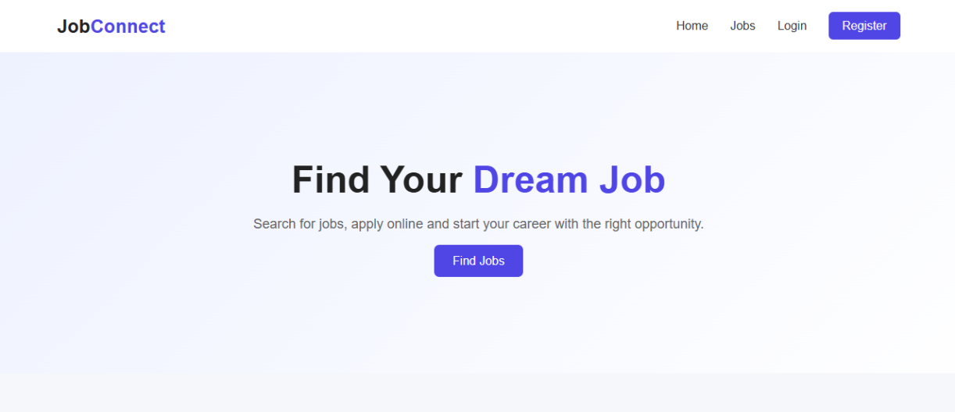

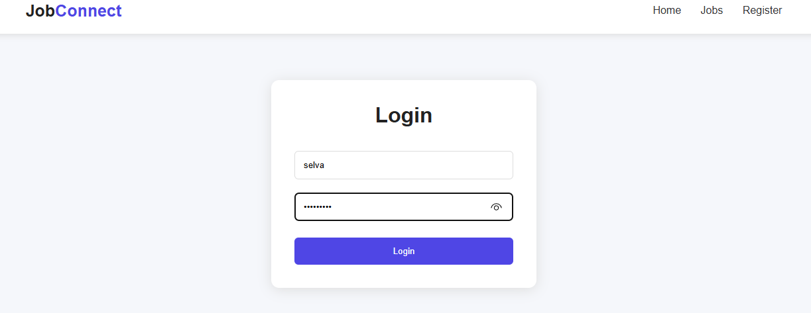

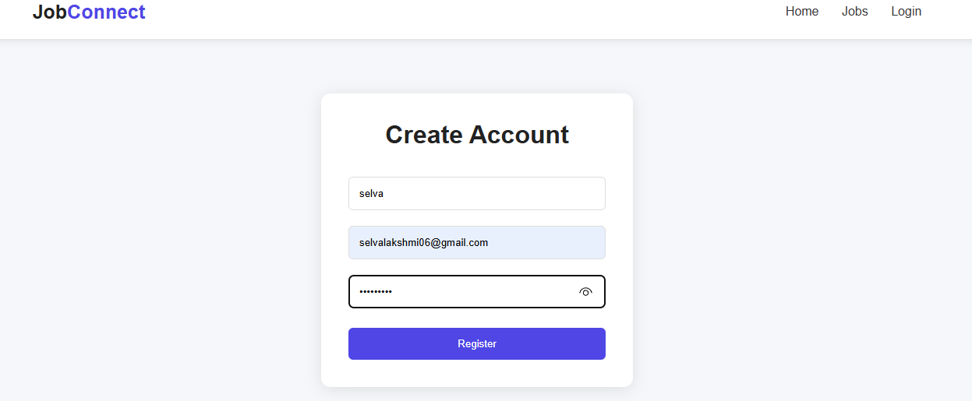

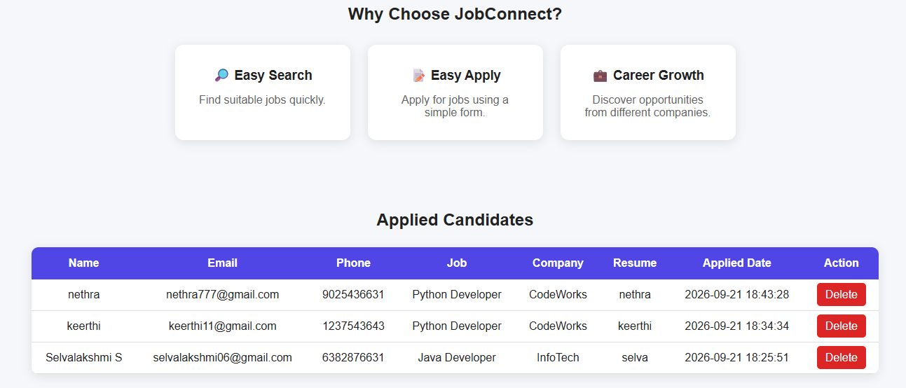

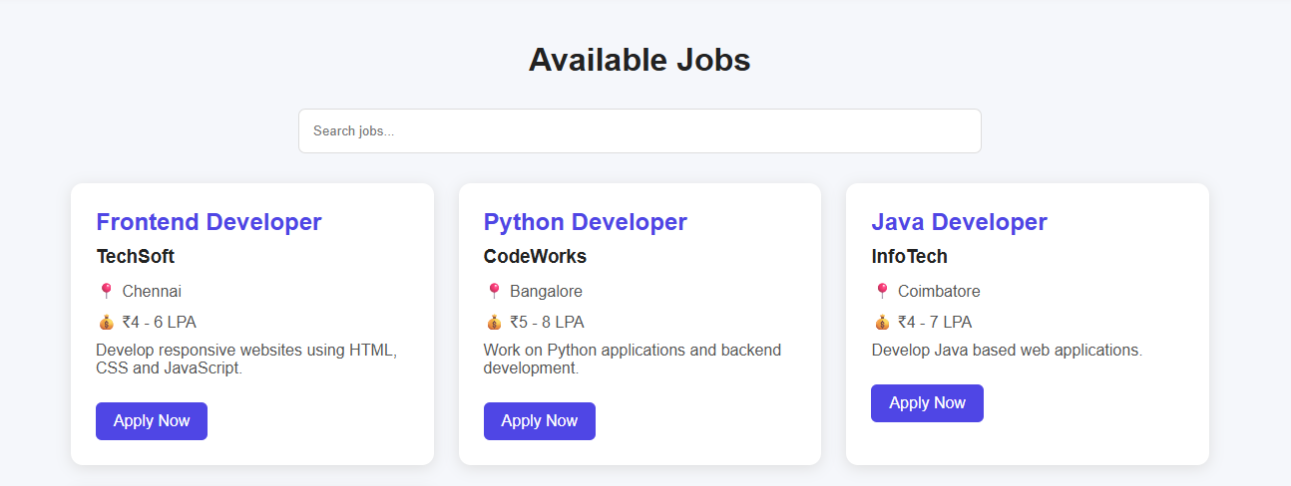

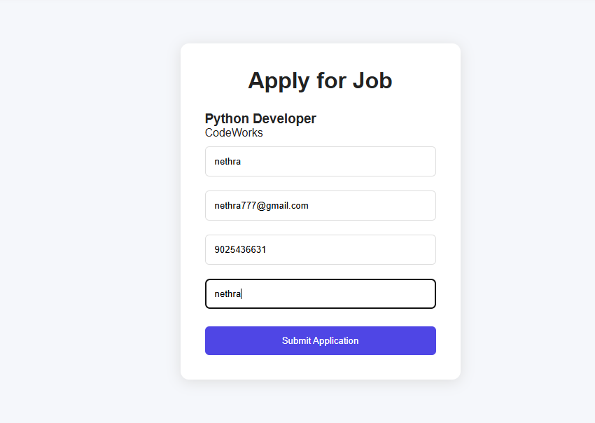

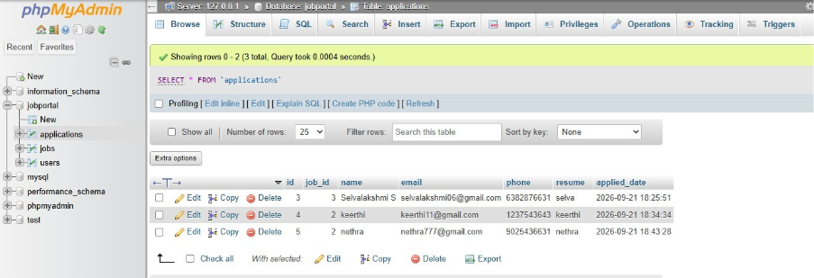

References
The project development can refer to resources such as Oracle Java Documentation, W3Schools Web Development Tutorials, MDN Web Docs, MySQL Documentation, and GeeksforGeeks for understanding programming concepts, web technologies, database management, and application development. These resources provide technical guidance for designing and implementing the Online Job Portal.
Conclusion
The Online Job Portal provides an effective and convenient solution for connecting job seekers and employers in a single platform. It simplifies job searching, online applications, vacancy management, and recruitment activities while reducing manual effort and time. The system can be further enhanced with features such as resume uploading, email notifications, advanced job recommendations, interview scheduling, and skill-based job matching.

